Sandia National Laboratories Weapons Science & Technology

Nuclear Weapons

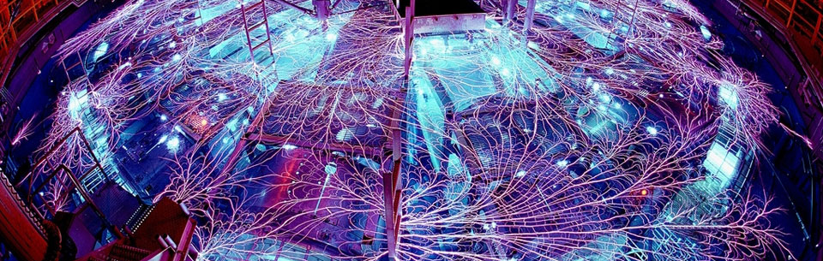

National labs provide the science and technology to maintain and certify the nuclear stockpile in the absence of full-scale weapons testing. The facilities and expertise used to fulfill this mission over the last 60 years are even more critical as the stockpile ages, the total number of weapons decreases (greatly increasing the relative worth of each remaining weapon), and the security threat to the stockpile changes.

Science and technology strengths:

* Improve response to evolving threats through technological advances in safety and security systems
* Increase understanding of aging components and materials in stockpile weapons, which allows for focused upgrades and/or retirements to maintain the highest reliability
* Compensate for the loss of underground testing and key research test reactors as a result of evolving national policy and cost reductions
* Provide discovery and solutions to avoid technological surprise

The nation’s best defense in anticipating future nation state and terrorist capabilities is a strong science and technology core.

These science and engineering capabilities support Sandia’s nuclear weapons program:

Radiation Effects Sciences

Sandia is a world leader in pulsed power science and technology. Sandia measurements of nuclear material properties under extreme pressure conditions are used to strengthen our understanding of nuclear explosive performance and provide confidence in nuclear weapon certification without underground nuclear testing. At the Z machine, Sandia’s pulsed power accelerator facility, experiments simulate the radiation effects of nuclear weapon explosions and provide critical insights into weapon physics.

Computer & Information Sciences

Sandia’s vast parallel computing power allows a deeper understanding of phenomena needed to advance weapon and component design, and help test devices against inadvertent or deliberate unauthorized use.

Materials Science

The nation depends on breakthrough materials science to meet critical security imperatives. Sandia explores, develops, and provides new materials with dramatically enhanced properties, functions, and behaviors to meet future requirements in critical systems. As systems change and age, materials science delivers answers regarding the chemical and physical mechanisms that underlie those changes.

Nanodevices & Microsystems

Microelectronic circuits have a strong history of dramatically improving the performance, functionality, and reliability of national security platforms. Sandia’s 400,000 square-foot MESA Complex is used in design, microsystem integration, failure analysis and reliability physics, modeling and simulation, component engineering, testing, and packaging.

Engineering Sciences

Sandia's engineering sciences discipline leads the nation in engineering transitions in advanced, highly critical systems by integrating theory development, experimental discovery and diagnostics, modeling, and computational approaches to increase understanding of complex behavior in engineered systems.

http://www.sandia.gov/